INTERNATIONAL STANDARD
ISO 29481-3

First edition
2022-09

Building information models — Information delivery manual —
Part 3:

Data schema
Modèles des informations de la construction — Protocole d’échange d’informations —
Partie 3: Schéma de données

Reference number ISO 29481-3:2022(E)

 COPYRIGHT PROTECTED DOCUMENT
© ISO 2022
All rights reserved. Unless otherwise specified, or required in the context of its implementation, no part of this publication may be reproduced or utilized otherwise in any form or by any means, electronic or mechanical, including photocopying, or posting on the internet or an intranet, without prior written permission. Permission can be requested from either ISO at the address below or ISO’s member body in the country of the requester.
ISO copyright office
CP 401 • Ch. de Blandonnet 8 CH-1214 Vernier, Geneva Phone: +41 22 749 01 11
Email: copyright@iso.org
Website: www.iso.org Published in Switzerland

Contents Page

Foreword v
Introduction vi
- Scope 1
- Normative references 1
- Terms and definitions 1
- Overview of the IDM schema 2
  - Naming convention 2
  - Restriction notation 2
  - Overall structure of the IDM schema 3
- Information delivery manual 5
- Specification identifier (specId) 6
- Authoring 7
  - General 7
  - Change log 9
  - Author 9
  - Committee 10
  - Publisher 10
- Use case 11
  - General 11
  - Summary 13
  - Aim and scope 13
  - Use 13
  - Standard project phase 13
  - Local project phase 14
  - Region 14
  - Construction entity 15
  - Business rule 15
  - Actor 16
  - Benefits 16
  - Limitations 16
  - Required resources 16
  - Required competencies 17
  - Reference 17
  - User-defined property 17
  - Classification 18
  - Outcomes 18
  - Information requirements 18
  - Description 19
  - Image 19
- Business context map 19
  - General 19
  - Process map 21
    - General 21
    - Data object and ER 21
  - Interaction map 21
    - General 21
    - Transaction map 21
  - Diagram 22
- Exchange requirement 22
  - General 22
  - Information unit 24
    - General 24
    - Examples 25
    - Corresponding external element 25
  - Constraint 25
  - Corresponding MVD 26
- IDM code generation rules 26
Annex A (informative) The idmXML schema definition (idmXSD) 28
Annex B (informative) IDM specification stages 29
Bibliography 30

Foreword
ISO (the International Organization for Standardization) is a worldwide federation of national standards bodies (ISO member bodies). The work of preparing International Standards is normally carried out through ISO technical committees. Each member body interested in a subject for which a technical committee has been established has the right to be represented on that committee. International organizations, governmental and non-governmental, in liaison with ISO, also take part in the work. ISO collaborates closely with the International Electrotechnical Commission (IEC) on all matters of electrotechnical standardization.
The procedures used to develop this document and those intended for its further maintenance are described in the ISO/IEC Directives, Part 1. In particular, the different approval criteria needed for the different types of ISO documents should be noted. This document was drafted in accordance with the editorial rules of the ISO/IEC Directives, Part 2 (see www.iso.org/directives).
Attention is drawn to the possibility that some of the elements of this document may be the subject of patent rights. ISO shall not be held responsible for identifying any or all such patent rights. Details of any patent rights identified during the development of the document will be in the Introduction and/or on the ISO list of patent declarations received (see www.iso.org/patents).
Any trade name used in this document is information given for the convenience of users and does not
constitute an endorsement.
For an explanation of the voluntary nature of standards, the meaning of ISO specific terms and expressions related to conformity assessment, as well as information about ISO’s adherence to the World Trade Organization (WTO) principles in the Technical Barriers to Trade (TBT), see www.iso.org/iso/foreword.html.
This document was prepared by Technical Committee ISO/TC 59, Buildings and civil engineering works, Subcommittee SC 13, Organization and digitization of information about buildings and civil engineering works, including building information modelling (BIM), in collaboration with the European Committee for Standardization (CEN) Technical Committee CEN/TC 442, Building Information Modelling (BIM), in accordance with the Agreement on technical cooperation between ISO and CEN (Vienna Agreement).
A list of all parts in the ISO 29481 series can be found on the ISO website.
Any feedback or questions on this document should be directed to the user’s national standards body. A
complete listing of these bodies can be found at www.iso.org/members.html.

Introduction
This document specifies a machine applicable, readable and transferable (SMART) data schema for the efficient development, management and reuse of information delivery manual (IDM) specifications based on ISO 29481-1. ISO 29481-1 sets out a methodology for describing the processes and information requirements for a defined purpose within the development or management of an asset. In the absence of a standard data schema for exchanging and sharing the contents of IDMs in an electronic format, IDM specifications have historically been developed as either a static document file or as a data file specified in a proprietary data format. Consequently, their contents cannot be efficiently exchanged, shared and reused. The goal of this document is to define a standard data schema in order to expedite the development and sharing of the IDM specifications to meet the rapidly increasing demand for various building information modelling (BIM) use cases (UCs).
Using extensible markup language (XML), this document specifies a data schema for authoring, exchanging and sharing an IDM specification defined by ISO 29481-1. The data schema is referred to as the idmXML schema definition (idmXSD). idmXSD aims to allow users to electronically store, search, share, exchange and reuse IDM specifications and their contents, including metadata such as authors, dates, languages, revision history and supported project phases, as well as detailed descriptions of each information requirement. In addition, this document specifies the IDM code generation rules based on their key properties.
Use of this document will improve the interoperability of IDM specifications and their contents, providing tight digital links between the components of an IDM specification and to external data definitions such as ISO 16739-1 (industry foundation classes, IFC), ISO 12006-3, ISO 19650-1, ISO 23386, ISO 23387, EN 17412-1 (level of information need) and ISO 21597-1 (information container for linked document delivery), as well as model view definitions (MVDs) of standard data schemas.

Single user licence only, copying and networking prohibited

INTERNATIONAL STANDARD ISO 29481-3:2022(E)

Building information models — Information delivery manual —
Part 3:

Data schema

Scope
This document is the technical addition to the methodology set out in ISO 29481-1. It defines a specification to store, exchange and read information delivery manual (IDM) specifications in a standardized and machine-readable way.

Normative references
The following documents are referred to in the text in such a way that some or all of their content constitutes requirements of this document. For dated references, only the edition cited applies. For undated references, the latest edition of the referenced document (including any amendments) applies.
ISO 639-1, Codes for the representation of names of languages — Part 1: Alpha-2 code
ISO 3166-1, Codes for the representation of names of countries and their subdivisions — Part 1: Country code
ISO 8601-1, Date and time — Representations for information interchange — Part 1: Basic rules
ISO 22263, Organization of information about construction works — Framework for management of project information
ISO 29481-1:2016, Building information models — Information delivery manual — Part 1: Methodology and format

Terms and definitions
For the purposes of this document, the terms and definitions given in ISO 29481-1 and the following apply.
ISO and IEC maintain terminology databases for use in standardization at the following addresses:
- ISO Online browsing platform: available at https://www.iso.org/obp
- IEC Electropedia: available at https://www.electropedia.org/
3.1

attribute
XML construct that modifies or provides descriptive metadata about an element’s content
[SOURCE: ISO 20616-1:2021, 3.7, modified — The term “XML attribute” has been deleted. The phrase “included within the start tag of an XML element” has been removed and “that element’s content” has been replaced with “an element’s content”.]
3.2

information delivery manual code IDM code
code for an IDM specification (3.3) created based on the key identifying features of an IDM specification

3.3

information delivery manual specification IDM specification
instance of an IDM and its components
3.4

use case UC
description of an information use for a specific purpose by one or more actors and/or systems
3.5

business context map
description of the information flow in a business context represented in the form of a process map or
interaction map

Overview of the IDM schema

Naming convention
The naming convention shown below is used for the IDM schema elements.
- The camel case convention shall be used for the naming of IDM schema elements.
- Except for the terms below, all the terms shall be spelled out:
  - idm: information delivery manual;
  - uc: use case;
  - er: exchange requirement;
  - pm: process map;
  - im: interaction map;
  - tm: transaction map;
  - id: identifier.
- Elements that represent descriptions, a group or a set shall be specified using a plural form.
EXAMPLE benefits, limitations, requiredResources, requiredCompetencies.

Restriction notation
The following XSD restriction notation is used for the IDM data schema.
- PK: primary key.
- Required: mandatory.
- Optional: not mandatory.
- The 1:1 restriction depicts that both the minimum and maximum occurrence of an element is 1. This
means there shall be one element.
- The 0:1 restriction depicts that the minimum occurrence of an element is 0 and the maximum
occurrence is 1.
- The 0:* restriction depicts the zero to many relationship, which is represented as minOccurs = "0" to maxOccurs = "unbounded" in the XML schema.

Overall structure of the IDM schema
The idmXSD consists of the idm element, its three core components (i.e. UC, business context map and ER), and the relations and properties related to them.
- An IDM specification consists of a UC, business context maps and an ER.
- A UC shall include the header information specified in ISO 29481-1 and other metadata sufficient to provide the context and the scope of an IDM.
- A business context map visually and formally represents the information delivery processes for a UC. ISO 29481-1 requires the exchange method and process to be specified in one or more PM and/ or IM.
- An ER defines the information required by a specific UC at an individual information-unit level; possibly with references to the elements of standard data schemas, such as CityGML[19], ISO 16739-1 (IFC), gbXML[17] or ISO 12006-3.
Clauses 5 to 11 define the entities, relationships, attributes and restrictions of the IDM schema. Figure 1 illustrates a conceptual view of the IDM schema. A downloadable link to the full idmXSD is provided in Annex A.

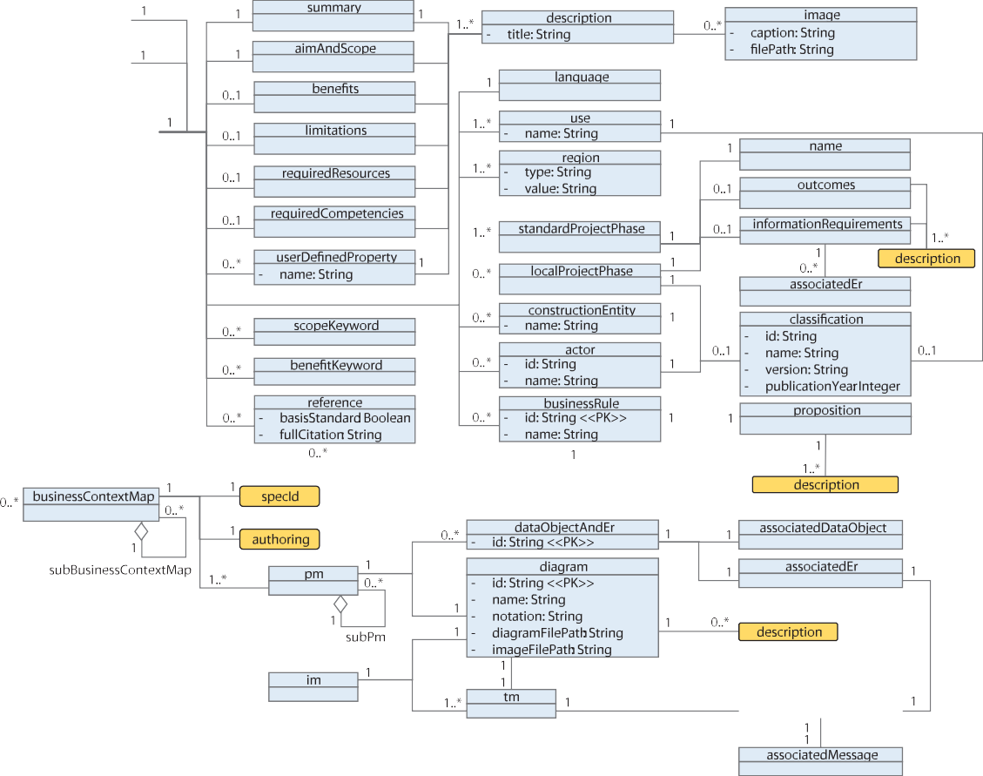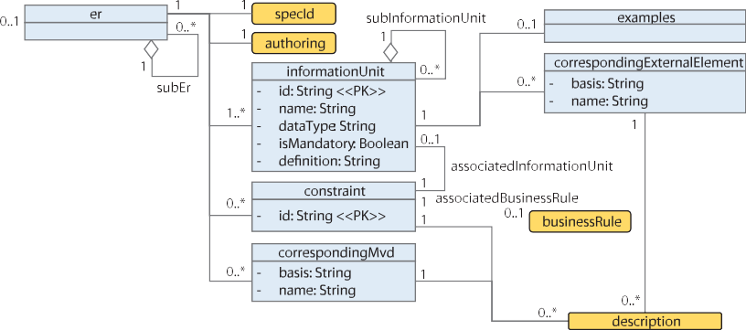

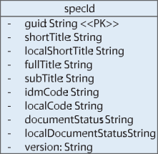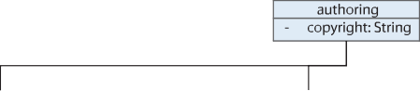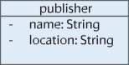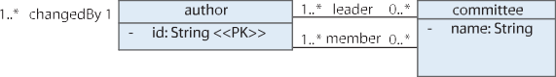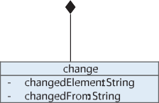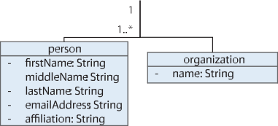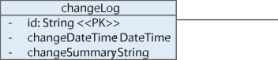

Figure 1 — Conceptual view of the IDM schema in the unified modelling language (UML) class diagram

Information delivery manual
The idm element is a wrapper of core IDM components – namely UCs, business context maps and ERs
(see Figure 2). The constraints between them are as follows.
- The idm element shall be the single root element in the idmXSD.
- An idm element shall be associated with a single uc element and a single er element.
- An idm element may contain zero to many businessContextMap elements.
- The businessContextMap element and the er element may be left unspecified during the initial development phase, to be detailed in a later version of the IDM specification as it is developed.
- An idm element may include zero to many subIdm elements. The other IDM components (i.e. the UC element, the businessContextMap element and the er element) may also include zero to many sub-elements.
This structure allows all the IDM components to be associated with multiple IDMs, UCs, business context maps and ERs, which can be specified by external groups.

Figure 2 — XSD diagram of the IDM element

Table 1 lists the elements, types and restrictions of the IDM element.

Table 1 — IDM’s elements

Name | Type | Restriction | Description
specId | element | 1:1 | The specification identification information  (see Clause 6 for details).
authoring | element | 1:1 | The author and change log information (see Clause 7 for details).
subIdm | element | 0:* | A subset of an IDM.
uc | element | 1:1 | An associated UC.
businessContextMap | element | 0:* | Associated business context maps.
NOTE The XML elements are shaded in grey. XML elements with sub-elements are depicted separately.

Table 1 (continued)

Name | Type | Restriction | Description
er | element | 0:1 | An associated ER.
NOTE The XML elements are shaded in grey. XML elements with sub-elements are depicted separately.

Specification identifier (specId)
Each IDM component shall have a set of identifiers. An IDM specification and its sub-UC, business context map and ER shall use four types of identifiers: a globally unique identifier (GUID), an IDM code, and user-defined full and short titles (guid, idmCode, fullTitle and shortTitle, respectively). Since an IDM specification can be specified in any language, the short title shall be provided in English. These are referred to as the “specId attribute group”. The specId attribute group shall include the attributes specified in Figure 3 and Table 2.

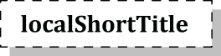
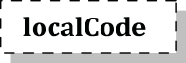

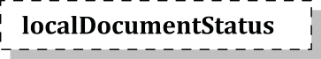


Figure 3 — XSD diagram of the specId

Table 2 — specId’s attributes

Name | Type | Restriction | Description
guid | string | PK | A globally unique identifier.
shortTitle | string | required | A running title or byname for an IDM specification in  English.
localShortTitle | string | optional | A running title or byname for an IDM specification in a local  language.
fullTitle | string | required | A full name of an IDM specification.
subTitle | string | optional | A supplementary title for an IDM specification.
idmCode | string | required | A human- and machine-readable code, generated based on the core metadata items of an IDM specification (see Clause 11 for details).
localCode | string | optional | A legacy identifier or a supplementary IDM identifier  generated according to a local code generation rule.
documentStatus | string | required | The status of an IDM specification, from the initiation stage to the official release stage.  The documentStatus shall be either one of NP (new proposal), WD (working draft), PUB (publication) or WDRL (withdrawal) (see Annex B for details).
localDocument-Status | string | optional | The status of an IDM specification according to the local  document release status.
version | string | optional | A combination of numbers and/or strings, which record the development of an IDM specification.

Authoring

General
The authoring element stores the author information and the change history of IDM specifications, including the changed contents, the principal or organization who created and changed the contents, and the change date. An IDM specification shall be written by at least one author or one committee. Authors can belong to one or more committees. The authoring element is composed of author, committee, changeLog and publisher. The authoring’s attributes and elements are specified in Figure 4 and Table 3.

E] attributes
E] attributes
id
copyright
changeDateTime
changeSummary

authoring El
changeLog $
v
1..*

change B-
changed From
0..*
E] attributes
id

- attributes
changed By
changedElement

lf'. author
  - .*

person
1..*

organization

committee J
o..*
E] attributes 1..*
name

member
J
'v
1..*

leader
E] attributes o..*
publisher B-
name
EE] constraints
location

Figure 4 — XSD diagram of the authoring attributes

Table 3 — Authoring’s attributes and elements

Name | Type | Restriction | Description
copyright | string | required | A description about the copyright ownership and/or licence  information.
changeLog | element | 1:* | The history of a specification: a chronological list of who created and changed the specification, as well as when the specification was created and changed (see 7.2 for details).
author | element | 0:* | A person or organization that creates or modifies the IDM specification (see 7.3 for details).
committee | element | 0:* | The authoring group of the IDM specification (see 7.4 for details).
publisher | element | 0:1 | The publisher of the IDM specification (see 7.5 for details).
NOTE The XML elements are shaded in grey. XML elements with sub-elements are depicted separately.

Change log
The changeLog consists of id, changeDateTime, changeSummary (content), changedBy (the author who made a change) and changes. The IDM user or developer can track the changes in the IDM specifications through the attributes in changeLog. The changeLog’s attributes and elements are specified in Tables 4 and 5.

Table 4 — changeLog’s attributes and elements

Name | Type | Restriction | Description
id | string | PK | A unique identifier assigned incrementally or sequentially to an item to uniquely identify it.
changeDateTime | dateTime | required | The date and time when the changes were made. The format shall be “YYYY-MM-DD” as specified by ISO 8601-1.
changeSummary | string | required | A description of the change summary made in a specification.
changedBy | element | 1:1 | The author who created or made changes. A reference to an id of the author element (see 7.3 for details).
change | element | 0:* | Each change instance in the changeLog.
NOTE The XML elements are shaded in grey. XML elements with sub-elements are depicted separately.

Table 5 — Change’s attributes

Name | Type | Restriction | Description
changedElement | string | required | A metadata element that was changed.
changedFrom | string | required | A value before each element has changed.

Author
The author element represents general information about the IDM creator and/or editor, such as emailAddress, name (firstName, middleName and lastName), affiliation and id. An author can be a person or an organization. The author’s attribute and elements are specified in Table 6. The person’s attributes are specified in Table 7. The organization’s attributes are specified in Table 8.

Table 6 — Author’s attribute and elements

Name | Type | Restriction | Description
id | string | PK | The unique identifier for  representing each author.
person | element | 1:* | A person who authors an  IDM specification.
organization | element | 1:* | An organized body of people who author an IDM specification.
NOTE The XML elements are shaded in grey.

Table 7 — Person’s attributes

Name | Type | Restriction | Description
firstName | string | required | The first name of the author.
middleName | string | optional | The middle name(s) of the author.
lastName | string | optional | The last name of the author.
emailAddress | string | optional | An email address of the author.
affiliation | string | optional | The affiliations of the author.

Table 8 — Organization’s attribute

Name | Type | Restriction | Description
name | string | required, unique | The name of an organization.

Committee
The committee element shall be used when an IDM specification is developed by a named committee of authors. The committee element includes name, leader, member, etc. The committee’s attribute and elements are specified in Table 9.

Table 9 — Committee’s attributes and elements

Name | Type | Restriction | Description
name | string | PK | The name of an authoring group.
leader | element | 0..* | The author who leads an IDM specification author team (a reference to the identifier of an author who belongs to a committee) (see 7.3 for details).
member | element | 0..* | A reference to the identifier of an author who belongs to  a committee (see 7.3 for details).
NOTE The XML elements are shaded in grey.

Publisher
The publisher element represents the entity that published the IDM specification. It is composed of the name and location. The publisher’s attributes are specified in Table 10.

Table 10 — Publisher’s attributes

Name | Type | Restriction | Description
name | string | required | The entity that published the IDM specification.
location | string | optional | The region (a country or a city) where the IDM specification  was published.

Use case

General
The UC element in the IDM schema can be understood as a collection or an extension of the overview information of a PM and an ER specified in ISO 29481-1. The UC attributes and elements are specified in Figure 5 and Table 11 to Table 32.

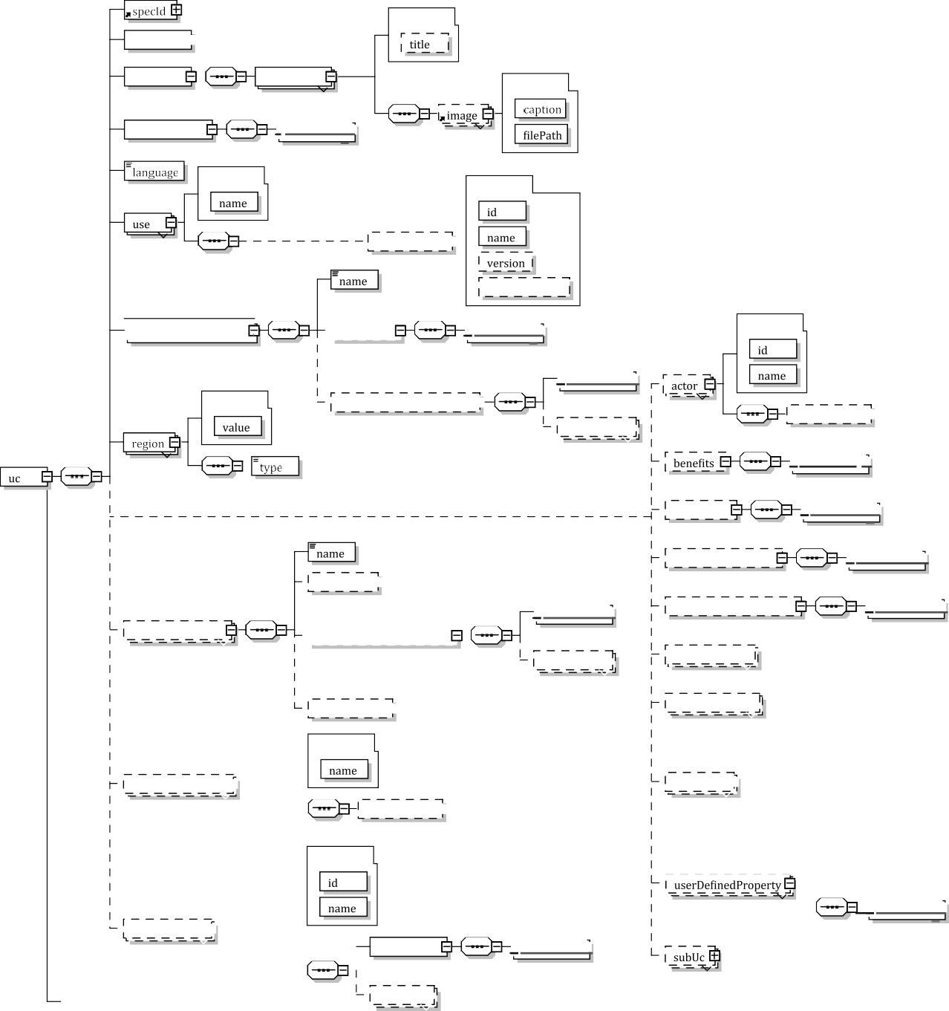

o..*
; associated Er
v
El attributes
"'authoring 1±1

summary
"'description
1..*
El attributes
aimAndScope
I"'description $
V
l..*
o..*
El attributes El attributes
1..*
"'classification B-
standardProjectPhasev I
l..*
I"
El attributes
1..*
El attributes
"'information Requirements El
I"'descriptionv$
l..*
O..*
"'classification 1±1
o..*
1..*
I"'description $
v
l..*
limitations
I
l..*
required Resources
"'outcomes 1±1
I"'description $
V
l..*
localProjectPhase
v O..*
-
I"'descriptionv$
l..*
requiredCompetencies
I"'descriptionv$
1..*
o..*
scopeKeyword
v O..*
"'classification 1±1
benefitKeyword
v
O..*
El attributes
El attributes
constructionEntitC
o..*
"'classification 1±1
reference B-
v 0..*
businessRulev=---'
El attributes
{
0..*
1"d'escription $
o..•
�L_
v
1..*
J
proposition
I"'descriptionv$
l..*
0..*
reference
v
fullCitation
basisStandard
v
"'description $
1±1 constraints
v
'description $
publication Year
El attributes
; associatedEr
v
"'informationRequirements
"'outcomes

Figure 5 — XSD diagram of the UC element

Table 11 — UC’s elements

Name | Type | Restriction | Description
specId | element | 1:1 | The IDM specification identification information  (see Clause 6 for details).
authoring | element | 1:1 | The author and changeLog information (see Clause 7 for details).
subUc | element | 0:* | A subset of a UC.
summary | element | 1:1 | A brief of the aim and scope, benefits, and other aspects of an IDM specification (see 8.2 for de-tails).
aimAndScope | element | 1:1 | The purpose and coverage of an IDM specification  (see 8.3 for details).
language | element | 1:1 | The language used to define an IDM specification,  which shall be in accordance with ISO 639-1.
use | element | 1:* | A method of utilizing information in a project for a  specific purpose (see 8.4 for details).
standardProjectPhase | element | 1:* | The stage of a project that an IDM specification is targeting in accordance with ISO 22263 (see 8.5 for details).
localProjectPhase | element | 0:* | The stage of a project that an IDM specification is targeting, based on a project life cycle classifi-cation system chosen by the authors (e.g. Generic  Process Protocol (GPP), the American Institute of Architects (AIA) or the Royal Institute of British Architects (RIBA)) (see 8.6 for details).
region | element | 1:* | A geographical area where a specified document  will be used (see 8.7 for details).
constructionEntity | element | 0..* | A type of construction product by function  (see 8.8 for details).
businessRule | element | 0:* | Operation, definition or constraint that can be applied to a set of data used within a particular process or activity (see 8.9 for details).
actor | element | 0:* | The role or discipline of the project participant who is sending and receiving information  (see 8.10 for details).
benefits | element | 0:1 | A description of the advantages that can be gained from a UC (see 8.11 for details).
limitations | element | 0:1 | A description of the weaknesses, scope or distinc-tive characteristics of a UC (see 8.12 for details).
requiredResources | element | 0:1 | A description of the resources that are prerequi-sites to begin a UC (see 8.13 for details).
requiredCompetencies | element | 0:1 | A description of the competencies required by a team member to conduct the activities specified in a UC (see 8.14 for details).
scopeKeyword | element | 0:* | A keyword that describes the scope of a UC.
benefitKeyword | element | 0:* | A keyword that describes the advantages that can be gained from a specified UC.
reference | element | 0:* | An external source, such as a standard, to which an IDM specification refers (see 8.15 for details).
userDefinedProperty | element | 0:* | An additional property to further describe a UC  (see 8.16 for details).
NOTE The XML elements are shaded in grey. XML elements with sub-elements are depicted separately.

Summary
An overall summary of the purpose, scope, benefits and other aspects of an IDM specification shall be specified using the summary element. A summary can be specified in multiple languages. However, the first (default) summary shall be specified in English for international readers. The summary’s element is specified in Table 12.

Table 12 — Summary’s element

Name | Type | Restriction | Description
description | element | 1:* | A textual or visual explanation.
NOTE The XML elements are shaded in grey. XML elements with sub-elements are depicted separately.

Aim and scope
The purpose and coverage of an IDM specification shall be specified using the aim and scope element. The aim and scope’s element is specified in Table 13.

Table 13 — Aim and scope’s element

Name | Type | Restriction | Description
description | element | 1:* | A textual or visual explanation.
NOTE The XML elements are shaded in grey. XML elements with sub-elements are depicted separately.

Use
The use element is a high-level classification of information uses within an asset’s life cycle. If the specified information use is based on any information-use classification system, the classification system can be specified using the classification element. The name of a use shall be defined in the form of a verb plus a noun, as specified in ISO 29481-1:2016, Table 1, Naming rule 3. The use’s attribute and element are specified in Table 14.
EXAMPLE ModelWall, EstimateCost, CheckModelCompliance.

Table 14 — Use’s attribute and element

Name | Type | Restriction | Description
name | string | required, unique | The name of a use.
classification | element | 0:1 | The classification system on which the specified information use is based (see 8.17 for details).
NOTE The XML elements are shaded in grey. XML elements with sub-elements are depicted separately.

Standard project phase
The standardProjectPhase’s attributes represent the targeting life cycle phases of the IDM specifications. In particular, the standard project phase, which follows ISO 22263, shall be specified for the design coordination or cooperation between international companies or institutions. ISO 22263 classifies a project life cycle into six phases: inception, brief, design, production, maintenance and demolition. An IDM can target one or more phases. Additionally, the outcomes and the information requirements of each phase can be described. The standard project phase’s attribute and elements are specified in Table 15.

Table 15 — standardProjectPhase’s attribute and elements

Name | Type | Restriction | Description
name | enumeration | required, unique | The name of the targeted life cycle phase based on ISO 22263: an enumeration of inception, brief, design, production, maintenance and demolition.
outcomes | element | 0:1 | The descriptions of the expected results once the selected life cycle phase is completed (see 8.18 for details).
informationRequirements | element | 0:1 | The descriptions of the information re-quired by the selected life cycle phase (see 8.19 for details).
NOTE The XML elements are shaded in grey. XML elements with sub-elements are depicted separately.

Local project phase
In addition to the standard project phase, the authors may specify a target life cycle phase(s) based on a project-phase classification system of their choice. This is referred to as the “local project phase(s)”. To specify a local project phase, the first step is to specify the project-phase classification system that the authors elect to use, with the classification element. The second step is to specify the target phases of an IDM. The local project phase’s elements are specified in Table 16.
EXAMPLE Project phases defined by the GPP, AIA or RIBA.

Table 16 — Local project phase’s elements

Name | Type | Restriction | Description
name | element | 1:1 | A stage name for the project life cycle phases, based on the project phase classification system chosen by the author.
outcomes | element | 0:1 | The descriptions of the expected results once the selected life cycle phase is completed (see 8.18 for details).
informationRequirements | element | 0:1 | The descriptions of the information required by the selected life cycle phase (see 8.19 for details).
classification | element | 0:1 | A classification system upon which the specified local  project phase is based (see 8.17 for details).
NOTE The XML elements are shaded in grey. XML elements with sub-elements are depicted separately.

Region
The target regions of an IDM shall be specified using the region element. The region’s attributes are specified in Table 17.

Table 17 — Region’s attributes

Name | Type | Restriction | Description
type | string | required, unique | A geographical area, either of a continent, a country or a user-de-fined region, where an IDM specification will be used.  The default value of the user-defined region is the “USR”.
value | string | required | A target region of an IDM specification.  The default value is “INT”, which stands for international (use). For continents and countries, the continent and country codes defined in ISO 3166-1 shall be used.

Construction entity
The facility type that an IDM specification aims to support shall be specified using the constructionEntity
element.
EXAMPLE A hospital facility, an airport, a railway, a data centre.
The classification element is the field to specify a standard classification system for construction entities (or facility type). An example of a standard classification system is OmniClassTM1) Table 11 - Construction Entities by Function[14]. The construction entity’s attribute and element are specified in Table 18.
Ghang Lee
2022-08-20 00:00:06
--------------------------------------------
Example OmniClassTM1) Table 11 Construction Entities by Function[14]

Table 18 — Construction entity’s attribute and element

Name | Type | Restriction | Description
name | string | required, unique | A construction entity of a project in which the targeted specification is based on the chosen classification element.
classification | element | 0:1 | A classification system that the specified construction entity is based on (see 8.17 for details).
NOTE The XML elements are shaded in grey. XML elements with sub-elements are depicted separately.

Business rule
The businessRule element describes the operations, definitions and constraints that can be applied to the set of data used within a particular process or activity. A business rule is composed of id, name, proposition and references. The business rule’s attributes and elements are specified in Table 19. The proposition’s element is specified in Table 20.

Table 19 — Business rule’s attributes and elements

Name | Type | Restriction | Description
id | string | PK | An identifier for a business rule, unique at least within a specification.
name | string | required, unique | An author-defined short title for a business rule, not unique (e.g. aggregate electric elements to a distribution point).
proposition | element | 1:1 | A description of the rule (e.g. only occurrences of particular types of electrical distribution elements can be aggregated within a distribution point). The proposition may include a graphical example.
reference | element | 0:* | An external source, such as a standard, to which a business rule refers. The reference element refers to the reference element of the UC element (see 8.15 for details).
NOTE The XML elements are shaded in grey. XML elements with sub-elements are depicted separately.

Table 20 — Proposition’s element

Name | Type | Restriction | Description
description | element | 1:* | A textual or visual explanation.
NOTE The XML elements are shaded in grey. XML elements with sub-elements are depicted separately.

1) OmniClassTM is an example of a suitable product available commercially. This information is given for the convenience of users of this document and does not constitute an endorsement by ISO of this product.

Actor
The actor element specifies the actors who send and receive the required information (i.e. ER). The actor is a person, organization or organizational unit (such as a department or team) involved in a facility’s life cycle process. More than one actor can send and receive an ER. Authors can choose a standard classification system for the actor (role) type. The classification element allows the authors to specify the actor classification standard of their choice. Two examples of such standards are OmniClassTM Table 33 - Disciplines[15] and OmniClassTM Table 34 - Organizational Roles[16]. The actor’s attributes and elements are specified in Table 21.

Table 21 — Actor’s attributes and elements

Name | Type | Restriction | Description
id | string | required | A unique identifier for the actor.
name | string | required, unique | A role name for the actor who is involved in the project.
classification | element | 0:1 | The classification system from which the specified actor  role is drawn (see 8.17 for details).
NOTE The XML elements are shaded in grey. XML elements with sub-elements are depicted separately.

Benefits
The advantages of providing required information shall be specified using the benefits’ element. The benefits’ element is specified in Table 22.

Table 22 — Benefits’ element

Name | Type | Restriction | Description
description | element | 1:* | A textual or visual explanation.
NOTE The XML elements are shaded in grey. XML elements with sub-elements are depicted separately.

Limitations
The limitations in delivering required information (e.g. temporal, scope or contractual limitations) shall be specified using the limitations element. The limitations’ element is specified in Table 23.

Table 23 — Limitations’ element

Name | Type | Restriction | Description
description | element | 1:* | A textual or visual explanation.
NOTE The XML elements are shaded in grey. XML elements with sub-elements are depicted separately.

Required resources
The resources required to deliver the required information shall be specified using the requiredResources element. The required resources’ element is specified in Table 24.

Table 24 — Required resources’ element

Name | Type | Restriction | Description
description | element | 1:* | A textual or visual explanation.
NOTE The XML elements are shaded in grey. XML elements with sub-elements are depicted separately.

Required competencies
The competencies, knowledge and skills required to deliver the required information shall be specified using the requiredCompetencies element. The requiredCompetencies’ element is specified in Table 25.

Table 25 — requiredCompetencies’ element

Name | Type | Restriction | Description
description | element | 1:* | A textual or visual explanation.
NOTE The XML elements are shaded in grey. XML elements with sub-elements are depicted separately.

Reference
An external source of information, such as a standard or other types of references, to which an IDM specification refers, shall be specified using the reference element. The reference’s attributes are specified in Table 26.

Table 26 — Reference’s attributes

Name | Type | Restriction | Description
basisStandard | boolean | required | An attribute that indicates whether or not the referenced standard forms the basis of the IDM specification.
fullCitation | string | required, unique | The full citation of a reference.

EXAMPLE
ISO standard:
ISO/TR 12353-3:2013, Road vehicles — Traffic accident analysis — Part 3: Guidelines for the
interpretation of recorded crash pulse data to determine impact severity
Printed book or monograph:
GREAT BRITAIN. Data Protection Act 1984. Schedule 1, c35, Part 1, Clause 7. London: HMSO
Electronic book or monograph:
INTERNET ENGINEERING TASK FORCE (IETF). RFC 3979: Intellectual Property Rights in IETF Technology [online]. Edited by S. Bradner. March 2005 [viewed 2020-09-09]. Available at https://www
.ietf.org/rfc/rfc3979.txt
Contribution to printed serial publication:
AMAJOR, L.C. The Cenomanian hiatus in the Southern Benue Trough, Nigeria. Geological Magazine. 1985,
122(1), 39–50. ISSN 0016-7568
Contribution to online serial publication:
STRINGER, John A., et al. Reduction of RF-induced sample heating with a scroll coil resonator structure for solid-state NMR probes. Journal of Magnetic Resonance [online]. Elsevier. March 2005, 173(1), 40–48 [viewed 2018-04-17]. Available at: http://dx.doi.org/10.1016/j.jmr.2004.11.015
NOTE Source: ISO/IEC Directives Part 2, 2021, 10.3[18].

User-defined property
If there are any additional properties of a UC, which an author considers relevant for the correct understanding or deployment of a UC, the userDefinedProperty element shall be used to specify them. The author shall give a name to the user-defined property. The user-defined property’s attribute and element are specified in Table 27.

Table 27 — User-defined property’s attribute and element

Name | Type | Restriction | Description
name | string | required, unique | The name of a user-defined property.
description | element | 1:* | A textual or visual explanation.
NOTE The XML elements are shaded in grey. XML elements with sub-elements are depicted separately.

Classification
The classification element shall be used to specify a classification system of an author’s choice. The classification shall include name, version and publicationYear. The classification’s attributes are specified in Table 28.

Table 28 — Classification’s attributes

Name | Type | Restriction | Description
id | string | PK | The identifier of a classification system.
name | string | required | The name of a classification system.
version | string | optional | The version of the classification system.
publicationYear | gYear | optional | The year when the classification system was published. The format is specified as YYYY.

Outcomes
The outcomes of the named UC at the end of a project phase shall be specified using the outcomes element. The outcomes’ element is specified in Table 29.

Table 29 — Outcomes’ element

Name | Type | Restriction | Description
description | element | 1:* | A textual or visual explanation.
NOTE The XML elements are shaded in grey. XML elements with sub-elements are depicted separately.

Information requirements
The information requirements of the named UC at the end of a project phase shall be specified using the informationRequirements element as a list of textual and/or visual descriptions. The descriptions may include a link to an exchange information requirement document specified in accordance with ISO 19650-2. Optionally, the description about information requirements can be linked to multiple ERs, which specify a list of required information units, through the associatedEr element. The information requirements’ attribute and element are specified in Table 30.

Table 30 — Information requirements’ attribute and element

Name | Type | Restriction | Description
description | element | 1:* | A textual or visual explanation or a link to an exchange information requirement document specified in accordance with ISO 19650-2.
associatedEr | element | 0:* | A reference to the associated ER’s GUID (see Clause 10 for details on the ER element).
NOTE The XML elements are shaded in grey.

Description
A description can be specified textually and visually using the description element. The description’s attribute and element are specified in Table 31.

Table 31 — Description’s attribute and element

Name | Type | Restriction | Description
title | string | optional | The name that distinguishes and groups each description, particularly when there are multiple descriptions associated with an element.
image | element | 0:* | A visual illustration of a description.
NOTE The XML elements are shaded in grey. XML elements with sub-elements are depicted separately.

Image
The name and the file path of an inserted image file shall be specified using the image element. The image’s attributes are specified in Table 32.

Table 32 — Image’s attributes

Name | Type | Restriction | Description
caption | string | required | The name of an image.
filePath | string | required | A file path to a diagram such as a URI or a relative file path.

Business context map

General
A business context map graphically represents how and when information is exchanged by whom, optionally with textual descriptions. The business context map’s attributes and elements are specified in Figure 6 and Table 33 to Table 39.



Figure 6 — XSD diagram of the business context map element

ISO 29481-1 indicates that there are two primary methods for specifying the nature and/or context of the information exchange, as well as its business processes: PM and IM/TM. ISO 29481-1 recommends ISO/IEC 19510 (business process model and notation, BPMN) as the default PM notation and ISO 29481-2 (IM/TM) as the default IM notation. A business context map may include zero to many sub-business context maps. The businessContextMap element includes specId, authoring, pm, im and subBusinessContextMap. The pm element may include the subPm elements. The im element shall include one or more tm elements. The business context map’s elements are specified in Table 33.

Table 33 — Business context map’s elements

Name | Type | Restriction | Description
specId | element | 1:1 | The specification identification information  (see Clause 6 for details).
authoring | element | 1:1 | The author and changeLog information (see Clause 7 for details).
subBusinessContextMap | element | 0:* | A subset of a business context map which provides detailed view of the business context map.
pm | element | 0:* | An associated PM diagram (see 9.2 for details).
im | element | 0:* | An associated interaction map model diagram (see 9.3 for details).
NOTE The XML elements are shaded in grey. XML elements with sub-elements are depicted separately.

Process map

General
The pm element is composed of diagram, dataObjectAndEr and subPm. The PM’s elements are specified
in Table 34.

Table 34 — PM’s elements

Name | Type | Restriction | Description
subPm | element | 0:* | A subset of a process map which provides elaborated representations of the process map.
diagram | element | 1:1 | An associated PM diagram file (see 9.4 for details).
dataObjectAndEr | element | 0:* | The mapping relationship between a data object in a PM diagram and an ER (see 9.2.2 for details).
NOTE The XML elements are shaded in grey. XML elements with sub-elements are depicted separately.

Data object and ER
The dataObjectAndEr element shall be used to link a data object in a PM diagram with its associated ERs. It shall be composed of id, associatedDataObject and associatedEr. The data object and ER’s attribute and elements are specified in Table 35.

Table 35 — Data object and ER’s attribute and elements

Name | Type | Restriction | Description
id | string | PK | A unique identifier for the mapping relationship  between a data object and an ER.
associatedDataObject | element | 1:1 | A reference to the associated data object in the  business context map.
associatedEr | element | 1:1 | A reference to the associated ER (see Clause 10 for details on the ER element).
NOTE The XML elements are shaded in grey.

Interaction map

General
An IM shall graphically represent an information-exchange process – optionally with textual descriptions focusing on the information transactions between actors (roles) – whereas a PM focuses on the information exchange between activities. An IM shall be composed of at least one TM to provide detailed views of an IM. Table 36 list the elements of the IM element.

Table 36 — IM’s elements

Name | Type | Restriction | Description
diagram | element | 1:1 | An associated IM/TM diagram file (see 9.4 for details).
tm | element | 1: * | An associated TM diagram (see 9.3.2 for details).
NOTE The XML elements are shaded in grey. XML elements with sub-elements are depicted separately.

Transaction map
A TM is a subcomponent of an IM and an elaborated description of the information transactions between two actors. The TM’s elements are specified in Table 37. The messageAndEr’s attribute and elements are specified in Table 38.

Table 37 — TM’s elements

Name | Type | Restriction | Description
diagram | element | 1:1 | An associated IM diagram file (see 9.4 for details).
messageAndEr | element | 0: * | The mapping relationship between a message in a TM diagram and an ER.
NOTE The XML elements are shaded in grey. XML elements with sub-elements are depicted separately.

Table 38 — messageAndEr’s attribute and elements

Name | Type | Restriction | Description
id | string | PK | A unique identifier for the mapping relationship  between a message and an ER.
associatedMessage | element | 1:1 | A reference to the associated message in the TM diagram.
associatedEr | element | 1:1 | A reference to the associated ER (see Clause 10 for details on the ER element).
NOTE The XML elements are shaded in grey.

Diagram
The diagram element shall be used to specify the PM, IM and TM diagram information. The diagram’s attributes and element are specified in Table 39.

Table 39 — Diagram’s attributes and element

Name | Type | Restriction | Description
id | string | PK | A unique identifier for a diagram.
name | string | required | A name of a diagram.
diagramFilePath | string | required | A file path to a diagram such as a URI or a relative file path.
imagFilePath | string | optional | A file path to a bitmap image of a diagram such as a URI or a relative file path.
notation | string | required | The name of a diagramming notation.
description | element | 0:1 | A description about a diagram (see 8.20 for details).
NOTE The XML elements are shaded in grey. XML elements with sub-elements are depicted separately.

Exchange requirement

General
An ER is composed of a list of specific information units and/or sub-ERs. An ER also includes the identification information (specId), the authoring information (authoring), the constraints, and the optional links to the external schema elements and/or to a corresponding MVD. An ER shall not be empty and shall have at least one information unit or a sub-ER. The ER’s attributes and elements are specified in Figure 7 and Table 40 to Table 45.

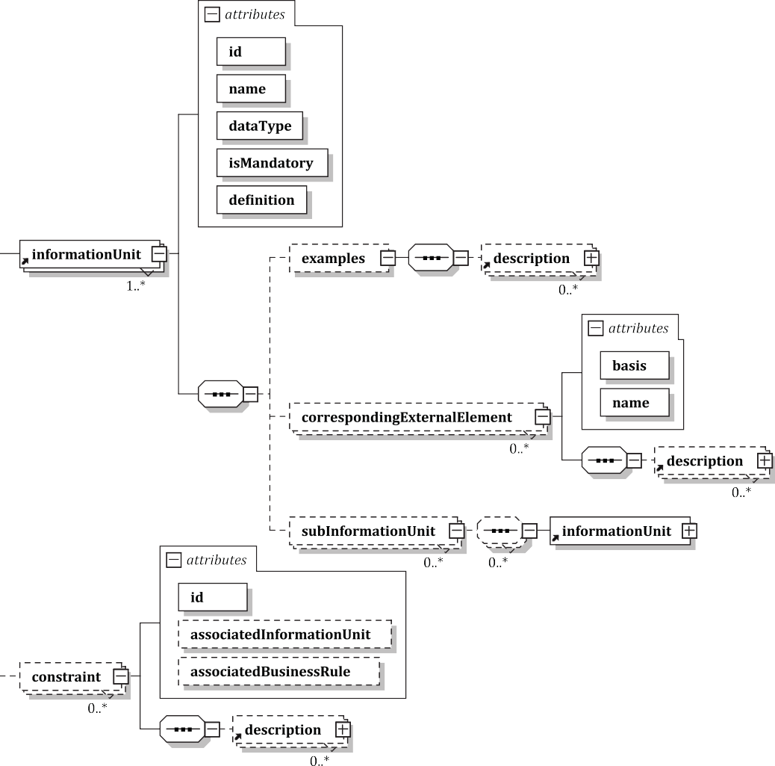

Figure 7 — XSD diagram of the ER element

Table 40 — ER’s elements

Name | Type | Restriction | Description
specId | element | 1:1 | The specification identification information  (see Clause 6 for details).
authoring | element | 1:1 | The author and changeLog information (see Clause 7 for details).
subEr | element | 0:* | A subset of an ER, which provides detailed view  of the ER.
informationUnit | element | 1:* | Specific piece of information required by a UC  (see 10.2 for details).
constraint | element | 0:* | The constraint that an ER needs to meet (see 10.3 for details).
correspondingMvd | element | 0:* | An optional link to the MVDs associated with an ER (see 10.4 for details).
description | element | 0:* | Comments or notes about an ER (see 8.20 for details).
NOTE The XML elements are shaded in grey. XML elements with sub-elements are depicted separately.

Information unit

General
ISO 29481-1 defines information unit as an individual information item. The informationUnit element includes id, name, dataType, isMandatory, definition, subInformationUnit, correspondingExternalElement and examples. The subInformationUnit element permits an information unit to be recursively specified as a collection of information units. Optionally, an information unit can be referenced to a specific element in an open standard schema or to a term(s) in a standard data dictionary via the element named correspondingExternalElement. Textual or graphical examples may be provided via the examples element. Table 41 lists the attributes and elements of the information unit element.
Ghang Lee
2022-08-20 00:03:43
--------------------------------------------
via the examples element

Table 41 — Information unit’s attributes and elements

Name | Type | Restriction | Description
id | string | PK | A unique identifier for an information  unit.
name | string | required | A name of the information unit.
dataType | string | required | A data type with which the information unit is exchanged.
isMandatory | boolean | required | An attribute that indicates whether an information unit is mandatory or optional.
definition | string | required | A description of an information unit.
examples | element | 0:1 | Textual and graphical descriptions of  instances of an information unit (see 10.2.2 for details).
correspondingExternalElement | element | 0:* | The mapping relation between an external element in an open standard data schema and a corresponding in-formation unit (see 10.2.3 for details).
subInformationUnit | element | 0:* | A collection of one or more informa-tion units which form a higher-level information unit.
NOTE The XML elements are shaded in grey. XML elements with sub-elements are depicted separately.

Examples
Examples of information units shall be specified using the examples’ element in Table 42.

Table 42 — Examples’ element

Name | Type | Restriction | Description
description | element | 1:* | A textual or visual explanation.
NOTE The XML elements are shaded in grey. XML elements with sub-elements are depicted separately.

Corresponding external element
The correspondingExternalElement element shall be used to link the information unit with corresponding external elements, such as the elements of ISO 16739-1 or term definitions based on ISO 12006-3. To specify the corresponding external elements, the user first needs to specify the basis schema upon which the external element is based, such as ISO 16739-1. Optionally, a description on the external element can be added using the description element. Table 43 describes the attributes and element in more detail.

Table 43 — correspondingExternalElement element’s attributes and element

Name | Type | Restriction | Description
basis | string | required | A basis schema or reference for the external element corresponding to an information unit. Some examples are IFC, CityGML[19] and ISO 12006-3.
name | string | required | The name of the external element corresponding to an  information unit.
description | element | 0:* | Comments or notes about the external element (see 8.20 for details).
NOTE The XML elements are shaded in grey. XML elements with sub-elements are depicted separately.

Constraint
The constraint element shall be used to specify the restrictions associated with information units such as the text length or the maximum and minimum data size. The constraint element is composed of the id, associatdInformationUnit, associatedBusinessRule and description. The information units associated with a constraint are specified via associatedInformationUnit. A constraint may be associated with zero to many business rules of a UC via associatedBusinessRule. Table 44 describes the attributes and element in more detail.

Table 44 — Constraint’s attributes and element

Name | Type | Restriction | Description
id | string | PK | A unique identifier for a constraint.
associatedInformationUnit | string | optional | A reference to the information unit element associated with a constraint (see 10.2 for the details on the information unit element).
associatedBusinessRule | string | optional | A reference to the business rule associated with a constraint (see 8.9 for the details on the business rule element).
description | element | 0:* | Comments or notes about the constraint (see 8.20 for details).
NOTE The XML elements are shaded in grey. XML elements with sub-elements are depicted separately.

Corresponding MVD
MVDs shall be specified separately and shall not be within the scope of the IDM specification. However, optionally, an MVD associated with an ER can be noted using the correspondingMvd. Some examples of an MVD are buildingSMART Coordination View, or subsets of open standard schemas such as ISO 16739-1, CityGML[19] and ISO 12006-3. Table 45 describes the attributes and element in more detail.

Table 45 — Corresponding MVD’s attributes and element

Name | Type | Restriction | Description
basis | string | required | A basis schema or reference for the MVD that  corresponds to an ER. Some examples are IFC, CityGML[19]  and ISO 12006-3.
name | string | required | The name of the MVD that corresponds to an ER, such as  Coordination View 2.0.
description | element | 0:* | Comments or notes about the corresponding MVD (see 8.20 for details).
NOTE The XML elements are shaded in grey. XML elements with sub-elements are depicted separately.

IDM code generation rules
An IDM code is a human-interpretable code. By having a human-interpretable code, unlike the purely machine-interpretable identifiers such as a GUID or a freely specified name, users shall be able to deduce the main content of an IDM specification by interpreting the code. An IDM code is composed of two parts: an IDM classification code and a document-oriented information code. The core attributes are the key identifying aspects, which have a high frequency of use in the existing IDM specifications: namely specification type, primary use, primary project phases (start and end), primary region and language. To provide additional document-oriented information, four more attributes shall be used: author/committee, initial date, short or abbreviated title, and document status. Figure 8 illustrates an example of an IDM code. Table 46 describes the definition, example and associated standard of the additional document-oriented attributes.

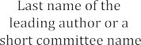
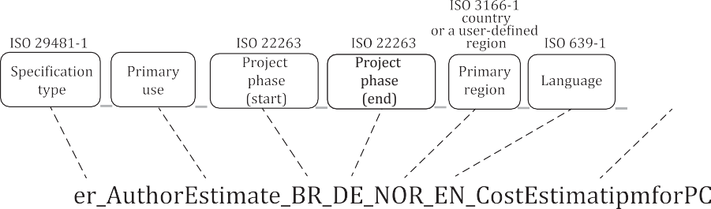
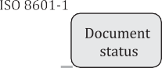
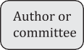
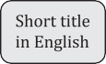
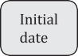

Figure 8 — IDM code

Table 46 — IDM code items

Name | Description | Examples | Associated standard
Spec. type | An initial of IDM specification types specified in 4.1. | Use case (UC) Process map (PM)  Exchange requirement  (ER)  Interaction map (IM) | ISO 29481-1
Primary use | The primary use of an IDM specification defined in the form of a verb plus a noun, as specified in ISO 29481-1:2016, Table 1, Naming  rule 3. | CoordinateDesign  LayoutConstructionWork | ISO 29481-1
Project phases (start and end) | The first and last project life cycle phases that an IDM specification is targeting, in accordance with ISO 22263. | Inception (IN) Brief (BR) Design (DE) Production (PR)  Maintenance (MA) Demolition (DE) | ISO 22263
Primary region | A target country for the primary use of the IDM, in accordance with ISO 3166-1 alpha 3. | Aruba (ABW) Afghanistan (AFG) Angola (AHO) Anguilla (AIA) | ISO 3166-1
Language | The language code of an IDM specification in accordance with ISO 639-1. | Chinese (CN) English (EN) | ISO 639-1
Short title in English | A short title or an abbreviated title in English without a white space. | CostEstimationForBridge
Author or committee | The last name of a leading author or a short name for a committee. | Smith  bSI
Initial date | The date when the first draft of an IDM specification was released, in accordance with ISO 8601-1. | YYYY-MM-DD  2020-03-17 | ISO 8601-1
documentStatus | The stage of an IDM specification in Annex B. | NP (new proposal) WD (working draft) PUB (publication)  WDRL (withdrawal)

Annex A
(informative)

The idmXML schema definition (idmXSD)

The idmXML schema can be downloaded from https://standards.iso.org/iso/29481/-3/ed-1/en.

Annex B
(informative)

IDM specification stages

There are multiple ISO and IEC standards for document stages. Three representative document-stage classifications used in ISO are the ISO harmonized stage code, ISO 7200 and IEC 82045-2. ISO 7200 and IEC 82045-2 use the same document stages. Since an IDM specification does not require a distinction between documents in the establishment stage as in ISO 7200 and those in use, nor between the original version and the revised version, it merges them into one stage: “publication (PUB)”. Similarly, since it is not necessary to separate withdrawn documents from deleted ones, the two stages are merged into “withdrawal (WDRL)”. On the other hand, an IDM specification may require a proposal stage and an approval stage, similar to an ISO standard. To suit its purpose, this document uses a simplified version of the document stages defined in the ISO harmonized stage code and ISO 7200 as shown in Table B.1.

Table B.1 — Comparison of document stages

ISO harmonized stage code | This document | ISO 7200/IEC 82045-2
00 Preliminary | NP (new proposal) | Initiation
10 Proposal | NP (new proposal) | Initiation
20 Preparatory | NP (new proposal) | Preparation
30 Committee | WD (working draft) | Establishment
40 Enquiry | WD (working draft) | Establishment
50 Approval | WD (working draft) | Establishment
60 Publication | PUB (publication) | Use
90 Review | PUB (publication) | Revision
95 Withdrawal | WDRL (withdrawal) | Withdrawal
95 Withdrawal | WDRL (withdrawal) | Deletion

Bibliography

- ISO 7200, Technical product documentation — Data fields in title blocks and document headers
- ISO 12006-3, Building construction — Organization of information about construction works —
Part 3: Framework for object-oriented information
- ISO 16739-1, Industry Foundation Classes (IFC) for data sharing in the construction and facility management industries — Part 1: Data schema
- ISO 19650-1, Organization and digitization of information about buildings and civil engineering works, including building information modelling (BIM) — Information management using building information modelling — Part 1: Concepts and principles
- ISO 19650-2, Organization and digitization of information about buildings and civil engineering works, including building information modelling (BIM) — Information management using building information modelling — Part 2: Delivery phase of the assets
- ISO 20616-1:2021, Graphic technology — File format for quality control and metadata — Part 1: Print requirements eXchange (PRX)
- ISO 21597-1, Information container for linked document delivery — Exchange specification — Part
1: Container
- ISO 23386, Building information modelling and other digital processes used in construction —
Methodology to describe, author and maintain properties in interconnected data dictionaries
- ISO 23387, Building information modelling (BIM) — Data templates for construction objects used in the life cycle of built assets — Concepts and principles
- ISO 29481-2, Building information models — Information delivery manual — Part 2: Interaction framework
- ISO/IEC 19510, Information technology — Object Management Group Business Process Model and
Notation
- IEC 82045-2, Document management — Part 2: Metadata elements and information reference model
- EN 17412-1, Building Information Modelling - Level of Information Need - Part 1: Concepts and principles
- CSI. OmniClassTM Construction Classification System. Table 11 – Construction Entities by Function.
Alexandria, VA, USA: CSI, 2014
- CSI. OmniClassTM Construction Classification System. Table 33 – Disciplines. Alexandria, VA, USA:
CSI, 2012
- CSI. OmniClassTM Construction Classification System. Table 34 – Organizational Roles. Alexandria,
VA, USA: CSI, 2012
- Green Building XML schema (gbXML). Available from: https://www.gbxml.org/About
_GreenBuildingXML_gbXML
- ISO. ISO/IEC Directives Part 2 — Principles and rules for the structure and drafting of ISO and IEC documents. Geneva: ISO, 2021
- Open Geospatial Consortium (OGC). CityGML Official Website. [online]. [viewed 2021-12-24].
Available from: https://www.ogc.org/standards/citygml

ICS 35.240.67; 91.010.01
Price based on 30 pages

© ISO 2022 – All rights reserved

